4. FIBONACCI WITHOUT RECURSION

**Algorithm**

1. **Start**.
2. Define a function printFib(int n).
3. If n < 1, print *"Invalid Number of terms"* and return.
4. Initialize two variables:
   * prev1 = 1
   * prev2 = 0
5. Repeat a loop from i = 1 to n:
   * If i == 1: print prev2.
   * Else if i == 2: print prev1.
   * Else:
     + Compute curr = prev1 + prev2.
     + Update values:
       - prev2 = prev1
       - prev1 = curr
     + Print curr.
6. In main():
   * Assign n (e.g., n = 9).
   * Call printFib(n).
7. **Stop**.

**PROGRAM**

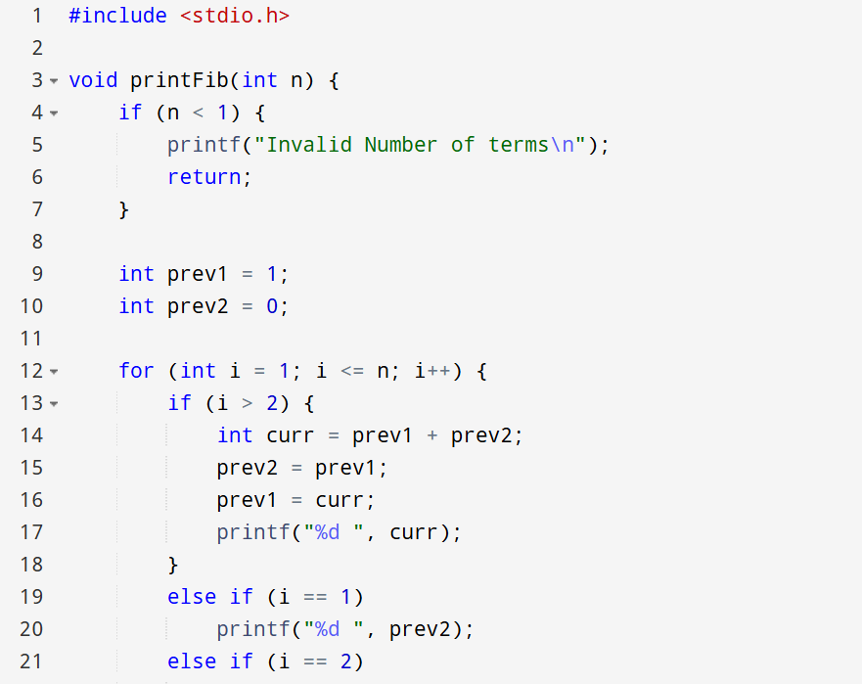

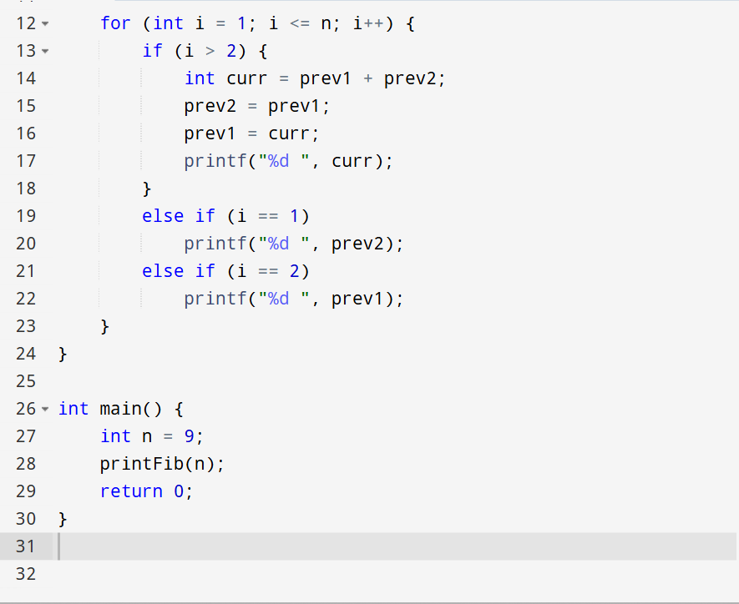

OUTPUT

0 1 1 2 3 5 8 13 21